CADDIE 5.0 (FLEX IN-HOUSE TOOL)

A PROJECT REPORT

***Submitted by***

**AYYANAR M**

(17-PCA-019)

***In partial fulfilment for the award of the degree of***

MASTER OF COMPUTER APPLICATIONS (MCA)

Under the guidance of

**PROF. CHRIS M JAYACHANDRAN**

**M.C.A., DWAP., M.Sc. (Psy)., M.Sc. (Vis.Com), M.Phil., Certified Int. Auditor for ISO 9001, Cert in Six Sigma (Black Belt)**



**LOYOLA COLLEGE (AUTONOMOUS)**

**CHENNAI-600034**

**APRIL - 2020**

**BONAFIDE CERTIFICATE**

This is to certify that the project work titled **‘CADDIE 5.0 (FLEX IN-HOUSE TOOL)’** is being submitted to the Department of Computer Applications (MCA), Loyola College (Autonomous), Chennai-34 by **AYYANAR M (17-PCA-019)** for the partial fulfilment for the award of degree of **MASTER OF COMPUTER APPLICATIONS** is a Bonafide record of work carried out by him, under my guidance and supervision.

**Head of the Department Project Guide**

Dr. C. Muthu Prof. Chris M Jayachandran

M. Sc., M. Tech., Ph. D MCA.,DWAP.,M.Sc. (Psy), M.Sc. (Vis.Com.),

M.Phil. Certified Int.Auditor for ISO 9001,

Cert in Six Sigma (Black Belt)

Submitted for the Viva-Voce Examination held on **.**

**Internal Examiner External Examiner**

**ACKNOWLEDGEMENT**

First of all I thank the almighty God for His blessings and grace by which I was able to complete this project successfully.

I extremely thank **Rev. Dr. A.Thomas S.J**, Principal, Loyola College for giving me a chance to pursue in this great institution.

I extend my heartfelt thanks to **Dr. C. Muthu**, The Head of the Department, Loyola College, for his constant encouragement.

I would like to thank **Prof. Chris M. Jayachandran**, my project guide for giving good guidance and a good environment for developing and completing my project.

I do really owe a token of gratitude to all the members of the Department of Computer Applications (MCA) both teaching and non-teaching staff for their direct and indirect assistance for the successful completion of the project.

**AYYANAR M**

**ABSTRACT**

CADDIE 5.0 is a Flex in-house tool for automating B2B (Business to Business) process that reduces cost involved in License. This is a web application which involved two main core applications called EWB (Engineering Work Bench) and PDP (Product Data Preparation). This helps user to generate reports that can be feeded into ERP systems like Baan. A project will be created after receiving Customer BOM from Site Contacts and data will be converted from Customer Standard to Flex Standard by a centralized application called PDP. Once the data is converted into Flex Standard, project will be crated as a single file like SNF (Standard neutral File). The SNF file will be loaded on EWB for generating multiple files like SNF1, SNF2, IN-BOM, and SMT (Surface Mount Technology). These files can be downloaded by feeding required input against Customer BOM in order to generate respective reports. Once the report is downloaded, it will be feeded into ERP systems in order to proceed with Parts Manufacturing in Site.

**LIST OF ABBREVIATIONS**

|  |  |
| --- | --- |
| **ABBREVIATIONS** | **EXPANSION/MEANING** |
| **ERP** | ENTERPRISE RESOURCE PLANNING |
| **TLA** | TOP LEVEL ASSEMBLY |
| **CPN** | CUSTOMER PART NUMBER |
| **MFR MAP** | MANUFACTURING MAPPING |
| **SNF** | STANDARD NUTRAL FILE |
| **BOM** | BILL OF MATERIAL |
| **PDP** | PRODUCT DATA PREPARATION |
| **EWB** | ENGINEERING WORK BENCH |
| **IN-BOM** | INLINE BILL OF MATERIAL |
| **MPT-BOM** | MASS PRODUCT INTRODUCTION BILL OF MATERIAL |
| **SMT** | SURFACE MOUNT TECHNOLOGY |
| **HLBT** | HAND LOAD BOTTOM |
| **HLTP** | HAND LOAD TOP |
| **SMBT** | SURFACE MOUNT BOTTOM |
| **TPBT** | THROUGH PART BOTTOM |
| **TPTP** | THROUGH PART TOP |
| **NLBT** | NO LOAD BUTTON |
| **NLTP** | NO LOAD TOP |

**LIST OF TABLES**

|  |  |  |
| --- | --- | --- |
| **TABLE NO** | **TABLE NAME** | **PAGE NO** |
| Table No 2.1 | Overall plan of the project | 5 |
| Table No 2.2 | Registration | 9 |
| Table No 2.3 | Save Versioned BOM | 9 |
| Table No 2.4 | BOM Repository | 10 |
| Table No 2.5 | Hardware Requirements | 11 |
| Table No 2.6 | Software Requirements | 11 |
| Table No 4.1 | Test results for unit testing | 19 |
| Table No 4.2 | Test results for integration testing | 21 |
| Table No 6.1 | Evaluation checklist | 32 |

**LIST OF FIGURES**

|  |  |  |
| --- | --- | --- |
| **FIGURE NO** | **FIGURE NAME** | **PAGE NO** |
| Fig No 2.1 | DFD Level 0 | 6 |
| Fig No 2.2 | DFD Level 1 | 7 |
| Fig No 2.3 | ER Diagram | 8 |
| Fig No 4.1 | Outline Iteration 1 | 18 |
| Fig No 4.2 | Outline Iteration 2 | 20 |
| Fig No 4.3 | Visual Studio Installer | 23 |
| Fig No 4.4 | Work Loads | 24 |
| Fig No 4.5 | Choose Individual Components | 25 |
| Fig No 4.6 | Install Language Packs | 25 |
| Fig No 4.7 | Installation Location | 26 |
| Fig No 4.8 | BOM Scrubbing Page | 28 |
| Fig No 4.9 | Save Versioned BOM Page | 28 |
| Fig No 4.10 | BOM Repository Page | 29 |
| Fig No 4.11 | Custom Reports Page | 29 |

**INDEX**

|  |  |  |
| --- | --- | --- |
| **CHAPTER** | **TABLE OF CONTENTS** | **PAGE NO** |
|  | List of Tables  List of Figures  List of Abbreviations | i  ii  iii |
| 1 | **THE PROBLEM**  1.0 Introduction  1.1 Description of the problem  1.2 Objectives  1.3 Description of existing solution  1.4 Evaluation of existing solution  1.5 Description of other possible solution  1.6 Evaluation of other possible solution  1.7 Conclusion | 1  1  1  1  2  2  2  3 |
| 2 | **DESIGN**  2.0 Introduction  2.1 Overall Plan  2.2 Description of the methods of solution  2.2.1 Data Flow Diagram  2.2.2 ER Diagram  2.2.3 Table design  2.3 Hardware requirements  2.4 Software requirements  2.5 Conclusion | 4  4  6  6  7  9  11  11  13 |
| 3 | **IMPLEMENTATION**  3.0 Introduction  3.1 Method of solution related to the problem  3.2 Accurate method of solution  3.3 Conclusion | 14  14  14  16 |
| 4 | **TESTING AND DOCUMENTATION**  4.0 Introduction  4.1 Testing strategies  4.2 Test Results  4.2.1 Unit Testing  4.2.2 Integration Testing  4.3 Technical documentation  4.4 User Documentation  4.5 Conclusion | 17  17  17  17  20  21  27  30 |
| 5 | **CONCLUSION**  5.0 Introduction  5.1 Evaluation  5.2 Future Enhancements  5.2.1 System Development  5.3 Technical skill learned  5.4 Conclusion | 31  31  32  33  33  33 |
| 7 | **BIBLIOGRAPHY**  **Appendix**  Screenshots  Attendance sheet  Document form  Weekly reports |  |

# CHAPTER 1

# THE PROBLEM

#### Introduction

In this chapter the existing system is explained in detail along with the proposed solution. A detailed study has been done on the existing system and by referring lots of web resources, the idea of using the proposed technology and language were selected based on the problems to be overcome and the features of the websites.

#### Description of the Problem

CADDIE is a Flex In-house Tool for automating B2B (Business to Business) process. The existing version is 4.0. This is a web application which is known as PDP (Product Data Preparation) tool. This tool converts customer BOM to flex standards. But the problem with CADDIE 4.0 is that PDP it is a third party licensed software which is of high cost and consumes a lot of time for converting the customer BOM file. Also it stores the data into database only as a single file called SNF (Standard Neutral File).Thus in the CADDIE is upgraded in the 5.0 version to meet out the drawbacks in the 4.0 version.

#### Objectives

* To download BaaN Comparison Report against uploaded customer BOM file
* To download SNF1 files then added to SNF2file
* To download SNF2 files then added to IN-BOM and SMT,MBI-BOM
* To upload all finalized reports in the ERP (BaaN)

#### Description of the existing solution

CADDIE 4.0 is a Flex in-house tool for automating B2B (Business to Business) process. This is a web application which is known as PDP (Product Data Preparation) tool. This tool converts customer BOM to FLEX standards. The PDP tool is a third party licensed software. Also it stores the data into database only as a single file called SNF(Standard Neutral File) which is fed into the ERP system Baan that are used in the manufacturing units.

#### Evaluation of existing solutions

**Advantages:**

* + - Using site wise CADDIE 4.0 is easy to use
    - It is easy to upload a file into ERP system like BaaN

#### Disadvantages:

* + - It is not cost effect since PDP is a third party tool
    - Takes time for converting a customer BOM to FLEX standard
    - Multiple files cannot be loaded into database since it allows only single SNF (Standard Neutral File) file to be uploaded

#### Description of other possible solutions

Instead of uploading PDP generated single file SNF (Standard Neutral File) into the ERP system Baan directly. The SNF is loaded into EWB (Engineering Work Bench) tool which generates multiple files like SNF1, SNF2, IN-BOM, SMT (Surface Mount Technology) to be loaded into the ERP system. This is currently being implemented in.net technology. It can also be developed in python and java but due to the industry standard compatibility .net is preferred.

#### Evaluation of other possible solutions Advantages:

* + - Enabling user to download comparison reports of Baan systems from web application with the required input will reduce time involved in data validation.
    - No cost for license
    - Time consumption
    - Easy to generate multiple files

#### Disadvantages:

* + - While the user tries to download multiple files at once there may be issues of system performance degradation.

#### Conclusion

This chapter stated the brief description of the problem, objectives, description and evaluation of the existing system and proposed system. The other possible ways to solve the problem and the importance of the proposed system compared with other possible solution have also been discussed. This leads to the design phase which is discussed briefly in the next chapter.

# CHAPTER 2 DESIGN

#### Introduction

After problem of the system, the next phase is processed system design. The objectives are the main goal to be achieved in design phase. They provide a milestone to understand the architecture of the project. The goal is to produce a mock-up design or representation of the working module through screens/wireframes.

#### Overall Plan of the Project

|  |  |  |  |  |
| --- | --- | --- | --- | --- |
| **PHASE** | **NAME** | **DESCRIPTION** | **START DATE** | **END DATE** |
| PHASE I | Problem | Initial plan and discussion for the  project and gathering the information | 25.11.2019 | 31.11.2019 |
| PHASE II | Design | 1. Designing Registration and Login form 2. Designing BOM Scrubbing page 3. Designing Saved Versioned BOM page 4. Designing BOM Repository page 5. Designing BOM Custom   Reports page | 02.01.2020  05.01.2020  12.01.2020  17.01.2020  21.01.2020 | 4.01.2020  11.01.2020  14.01.2020  20.01.2020  26.01.2020 |
| PHASE III | Implementation | 1. Implementing BOM Scrubbing Module 2. Implementing Save Versioned BOM Module 3. Implementing BOM Repository Module 4. Implementing Custom   Reports Module | 27.01.2020  03.02.2020  09.02.2020  21.02.2020 | 02.02.2020  08.02.2020  20.02.2020  28.02.2020 |
| PHSE IV | Testing | Testing the system | 02.03.2020 | 06.03.2020 |
| PHASE V | Documentation | 1. Creating user manual and project document 2. Creating Technical   Document | 09.03.2020  11.03.2020 | 10.03.2020  12.03.2020 |

*Table 2.1 Overall plan of the project*

#### 2.2 Description of Method of Solution

A best solution for the development of the project is to develop a system where by the front-end which should be user friendly as possible. Each module in the application is effectively handled with the help of front-end and back-end along with the tables, entity relationship diagram and data flow diagram. So the application is developed with the ASP.NET as the front-end, programming language is C# and SQL server as the back end. Forms have been designed for the user to enter the data and database tables have been designed for the data to get stored to it.

#### Data Flow Diagram

A Data Flow Diagram (DFD) is a graphical tool used to describe and analyse movement of data through system. It is a graphical representation of the flow of data through a computer system or a data or it looks at how data flows through a system. These are central tool and basic from which the other components are developed. The transformation of data from input to output, through processed may be described logically and independently of physical components associated with the system. The development of DFD is done at several levels. The flow diagram describes the boxes that describe computations, decisions, interactions & loops. It is important to keep in mind that the flow diagram are not flowcharts and should not include control elements.

**DFD Level 0**

CADDIE

FLEX IN- HOUSE TOOL

User

BOM Scrubbing, save versioned BOM, BOM

Repository, Custom reports

***Fig No 2.1*** *DFD Level 0*

### DFD Level 1

Registration DB

***Fig No2.2*** *DFD Level 1*

User Registration

Login

User

Custom Reports

BOM Repository

Save Versioned BOM

BOM Scrubbing

* + 1. **Entity Relationship**

Entity – Relationship Diagram: This depicts relationship between data objects. The attribute of each data objects noted in the entity- relationship diagram can see scribed using a data object description. Data flow diagram serves two purposes:

* To provide an indication of how data are transformed as they move through the system.
* To depict the functions that transformation the dataflow.

**ER Diagram**

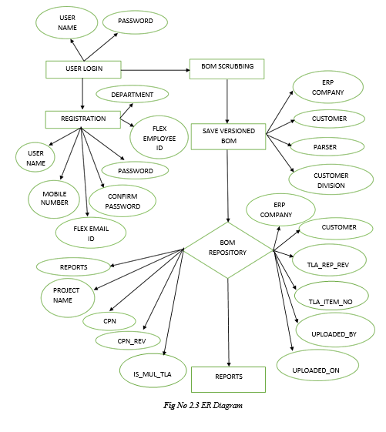

#### Table Design

* + - 1. **Table Name: CADDIE_Reg**

|  |  |  |  |  |  |
| --- | --- | --- | --- | --- | --- |
| **S NO** | **Field Name** | **Datatype** | **Size** | **Constraints** | **Description** |
| 1 | Username | Varchar | 30 | Not Null | It stores Name of the user |
| 2 | Mobile  Number | Int | 10 | Not Null | It stores Mobile number of  the user |
| 3 | Flex_email_id | Varchar | 50 | Primary key | It stores Email Id for the  individual user |
| 4 | Password | Varchar | 15 | Not Null | It stores Password for the  individual user |
| 5 | Confirm Password | Varchar | 15 | Not Null | It stores Confirm  Password for the individual user |
| 6 | Flex_Emp_Id | Int | 15 | Not Null | It stores to number of the  Flex Employee Id |
| 7 | Dep | Varchar | 15 | Not Null | It stores to Name of the  Department |

***Table No* 2.2** *Registration*

#### Table Name: Caddie_Save_BOM

|  |  |  |  |  |  |
| --- | --- | --- | --- | --- | --- |
| **S NO** | **Field Name** | **Datatype** | **Size** | **Constraints** | **Description** |
| 1 | ERP_Company | Varchar | 20 | Not Null | It stores ERP Company  Name of the save versioned BOM |
| 2 | Customer | Varchar | 50 | Not Null | It stores Customer name of  the save versioned BOM |
| 3 | Parser | Varchar | 50 | Not Null | It stores Parser name of the  save versioned BOM |
| 4 | Customer Division | Int | 10 | Primary key  Auto Increment | It stores various Customer  Division of the save versioned BOM |

***Table No* 2.3** *Save Versioned BOM*

#### Table Name: BOM_rep

|  |  |  |  |  |  |
| --- | --- | --- | --- | --- | --- |
| **S NO** | **Field Name** | **Datatype** | **Size** | **Constraints** | **Description** |
| 1 | ERP_Company | Int | 11 | Primary key  Auto Increment | It stores ERP company of the BOM repository |
| 2 | Customer | Varchar | 50 | Not Null | It stores customer of the  BOM repository |
| 3 | TLA_Rep_Rev | Varchar | 50 | Not Null | It stores TLA repository revision of the BOM  Repository |
| 4 | TLA_Item_No | Int | 20 | Not Null | It stores TLA item number of the BOM  Repository |
| 5 | Uploaded_By | Varchar | 50 | Not Null | It stores Uploaded by of  the BOM repository |
| 6 | Uploaded_On | Date | 15 | Not Null | It stores Uploaded on of  the BOM repository |
| 7 | Reports | Varchar | 50 | Not Null | It stores reports of the  BOM repository |
| 8 | Projects_Name | Varchar | 25 | Not Null | It stores Projects Name  of the BOM repository |
| 9 | CPN | Varchar | 15 | Not Null | It stores CPN of the  BOM repository |
| 10 | CPN_Rev | Varchar | 10 | Not Null | It stores CPN revision of  the BOM repository |
| 11 | Is_Mul_TLA | Varchar | 50 | Not Null | It stores Is Multiple TLA  of the BOM repository |

***Table No* 2.4** *BOM Repository*

#### Hardware Requirements

The hardware requirements may serve as the basics for a contract for the implementation of the system and should, therefore be a complete and consistent specification of the whole system.

|  |  |
| --- | --- |
| **Hardware** | **Minimum Requirements** |
| Processor | Intel core i3 2.10ghz or equivalent |
| RAM | 4GB or more |
| Hard Drive | 50GB or more |
| Clock speed | 2.0 GHz or more |
| Video display unit | 15 inches |
| Keyboard | Standard USB Keyboard with 108 keys |
| Mouse | Standard USB Optical mouse |

***Table No 2.5*** *Hardware Requirements*

#### Software Requirements

The software requirements provide a basis for creating the software requirements specification.

|  |  |
| --- | --- |
| **Software** | **Minimum Requirements** |
| Operating System | Windows 10 |
| Server-side Technology | .Net Framework 4.5 |
| Front End | Asp.Net |
| Back End | SQL Server 2017 |
| Programming Language | C# 8.0 |
| Scripting Language | JavaScript 1.8 |

***Table No 2.6*** *Software Requirements*

#### ASP.NET

It is an open-source server-side web application framework designed for web development to produce dynamic web pages. It was developed by Microsoft to allow programmers to build dynamic web sites, web applications and web services. It was first released in January 2002 with version 1.0 of the .NET Framework, and is the successor to Microsoft's Active Server Pages (ASP) technology. ASP.NET is built on the Common Language Runtime (CLR), allowing programmers to write ASP.NET code using any supported .NET language. The ASP.NET SOAP extension framework allows ASP.NET components to process SOAP messages. ASP.NET's successor is ASP.NET Core. It is a re- implementation of ASP.NET as a modular web framework, together with other frameworks like Entity Framework.

#### JavaScript

It is a high-level, interpreted programming language that conforms to the ECMA Script specification. It is a programming language that is characterized as dynamic, weakly typed, prototype-based and multi-paradigm. Alongside HTML and CSS, JavaScript is one of the core technologies of the World Wide Web. JavaScript enables interactive web pages and is an essential part of web applications. Most websites use it, and major web browsers have a dedicated JavaScript engine to execute it.

As a multi-paradigm language, JavaScript supports event-driven, functional, and imperative (including object-oriented and prototype-based) programming styles. It has APIs for working with text, arrays, dates, regular expressions, and the DOM, but the language itself does not include any I/O, such as networking, storage, or graphics facilities. It relies upon the host environment in which it is embedded to provide these features.

#### SQL Server

Microsoft SQL Server is a relational database management system developed by Microsoft. As a database server, it is a software product with the primary function of storing and retrieving data as requested by other software applications—which may run either on the same computer or on another computer across a network (including the Internet).

#### NHibernate

NHibernate is an [object-relational mapping](https://en.wikipedia.org/wiki/Object-relational_mapping) (ORM) solution for the [Microsoft](https://en.wikipedia.org/wiki/.NET_Framework)

[.NET](https://en.wikipedia.org/wiki/.NET_Framework) platform. It provides a [framework](https://en.wikipedia.org/wiki/Software_framework) for mapping an [object-oriented](https://en.wikipedia.org/wiki/Object-oriented_programming) [domain model](https://en.wikipedia.org/wiki/Domain_model) to a traditional [relational database.](https://en.wikipedia.org/wiki/Relational_database) Its purpose is to relieve the developer from a significant portion of relational data [persistence](https://en.wikipedia.org/wiki/Persistence_(computer_science))-related programming tasks. NHibernate is [free](https://en.wikipedia.org/wiki/Free_software) as [open](https://en.wikipedia.org/wiki/Open_source_software) [source software](https://en.wikipedia.org/wiki/Open_source_software) that is distributed under the [GNU Lesser General Public License](https://en.wikipedia.org/wiki/GNU_Lesser_General_Public_License). NHibernate is a port of [Hibernate.](https://en.wikipedia.org/wiki/Hibernate_(Java))

#### Conclusion

An effective application has been analyzed and designed by determining the various hardware and software requirements that would be needed for designing of the application. The design phase provides all the necessary information needed for the design of the application. All major changes have been done in the design phase itself.

#### Introduction

**CHAPTER 3 IMPLEMENTATION**

The next phase to the design phase is implementation phase. This is the phase where the theoretical representation of the process is carried out in a practical way. Implementation is a challenging phase where the developers tend to face lot of problems which were not expected at the beginning of the project. There could be many ways for implementing a solution but finding the accurate method of implementing is the most challenging task as far as the developers are concerned.

#### Method of solution related to the problem

The existing system is ongoing method of solution that solves the current need and gets application run in production. The idea is try to implement that solution for finding the accurate method of solution. The method of implementing the proposed system can be achieved through the method that adheres to the company standard. The proposed system is developed in many developers in the team parallelly. The developers develop in their local system and upload the completed modules in a network shared folder through LAN network so, that other developers can access the completed modules. The processed data is accessed to create multiple files in EWB tool that is to be uploaded in the ERP system Baan which act as the repository / server for manufacturing units to download the file for their utilization. This depicts the Client /Server architecture in the manufacturing units. To download the files manufacturing units connects to the server through the company’s Intranet.

#### Accurate method of solution

The accurate method of solution is where the objectives of the proposed system are really implemented. The existing solution though produced a method of solution, still there were some practical difficulties were felt and for overcoming these difficulties, accurate method has been found out. Although the existing solution converts the customer BOM to FLEX standard and generates single file using PDP tool, but it does not generate multiple files. So the developed system will generate the multiple files using EWB tool.

The major modules in which the solution was carried out.

* + - BOM Scrubbing Module
    - Save Versioned BOM Module
    - BOM Repository Module
    - Custom Reports Module

#### BOM Scrubbing Module

This process of BOM Scrubbing module is used to enter the Customer details, Name of the ERP Company, Division Number, Uploaded files and Parser details. Once all the details are the given the next process is to check whether all the given details are correct.

#### Save Versioned BOM

All the uploaded details are displayed after Save Version. The Save Version BOM has two types of file format such as Warning File and Error Log File.

#### Warning File Generates:

If the CADDIE show warning message then download CADDIE warning log.

#### Error Log File Generates:

If the CADDIE show Error Log message then download CADDIE Error log.

#### BOM Repository

BOM repository process is to check the all the BOM details in the saved versioned BOM. Once the checking process is over the next step is to go through the Customer Name, ERP company name, Uploaded on, Uploaded by, Reports, CPN (Customer Part Number) and the Custom Reports will be displayed.

#### Custom Reports

Clicking the custom reports button to generated to various files.

* + - * SNF1
      * SNF2
      * IN-BOM
      * SMT

After the downloaded files are feeded into ERP system to purpose of FLEX manufacturing site.

#### Conclusion

This phase is the actual coding and testing of the process by the development team. After each stage, the developer may demonstrate the work accomplished to the Business Analysts tweaks and enhancements may be required. It’s important in this phase for developers to be open-minded and flexible if any changes are introduced. This is normally the longest phase of the SDLC. The finished product here is input to the Testing and Documentation Phase.

#### Introduction

**CHAPTER 4**

**TESTING AND DOCUMENTATION**

Testing is one the process by which one detects the defects in the software. It is considered as the final opportunity for developing team to defect and convert or rectify any defecting that may appear during the software development stage. Software testing is a process of testing a program with the explicit intention of review in software products and related documentation for completion, correction, reliability and maintainability.

#### Testing Strategies

The purpose of carrying out testing is to find the errors. The main aim of the testers is to somehow break the system by passing values which normally system will not accept. Testing is the process of finding out faults and weaknesses in the system. Once the system has undergone testing, they can find out whether the software meets the required specifications or not. User expectations must be fulfilled by the system, in order to view whether the system meets the desired requirements testing is carried out. Testing will be carried out both using the permitted and non-permitted values for analyzing the performance of the system. In testing normal and abnormal values are used for testing.

#### Test Results

Testing strategy leads to test results. Actual testing will take place in this section. Test results describes an input, action or event an Expected output, to determine if a feature of an application is working correctly and come up with an output testing phase. As mentioned in the previous section the test deliverables such as test cases, Project/Module name, test c ase description. Test input, expected output, actual outputs are contained in the test case .Every module was tested under certain conditions and errors were rectified.

#### Unit Testing

This type of testing is performed by developers before the setup is handed over to the testing team to formally execute the test cases .Unit testing is performed by the respective developers on the individual units of source code assigned areas. The developers use test data that is different from the test data of the quality assurance team. The goal of unit testing is to isolate each part of the program and show that individual parts are correct in terms of requirements and functionality.

#### Test outline

**Case 1:** Inter-Field dependencies

**Case 1.1:** Testing the login form, user email id and password input field

*Fig No 4.1 Outline Iteration 1*

**Table Name:** Test results for unit testing

|  |  |  |  |  |  |
| --- | --- | --- | --- | --- | --- |
| **S.NO** | **Module Name** | **Test Condition** | **Test**  **Data/Input** | **Expected**  **Result** | **Actual**  **Result** |
| 1 | Login Module | Click on the login button after entering email id and password | Enter invalid  email id &password | Message prompts that  ―check username &  password‖ | Message prompts that  ―check username &  password‖ |
| 2. | Login Module | Click on the login button after entering email-id  and password | Enter valid  email id &password | Message prompts that  ―Successfully  logged in‖ | Message prompts that  ―Successfully  logged in‖ |
| 3. | Registration Module | Click on submit button after  entering the details of user | Enter invalid mobile number | Message prompts that  ―Mobile number should be of  10 digits‖ | Message prompts that  ―Mobile number should be of  10 digits‖ |
| 4. | Registration Module | Click on submit button after  entering the  details of user | Enter Invalid Email id | Message prompts that  ―Please check  Email ID‖ | Message prompts that  ―Please check  Email ID‖ |
| 5. | Registration Module | Click on submit button after  entering the  details of user | Enter valid Details | Message prompts that  ―Successfully  Registered‖ | Message prompts that  ―Successfully  Registered‖ |

|  |  |  |  |  |  |
| --- | --- | --- | --- | --- | --- |
| 6. | BOM  Scrubbing Module | Click on Next button after  entering the  details of parser | Enter the Null values | Message prompts that  ―Please enter  the values‖ | Message prompts that  ―Please enter  the values‖ |
| 7. | BOM  Scrubbing Module | Click on Next button after  entering the details of parser | Enter the valid details | Message Prompts that  ―Successfully go to Save versioned  BOM page‖ | Message Prompts that  ―Successfully go to Save versioned  BOM page‖ |
| 8. | Save Versioned BOM Module | Click on Save button after  displaying the details of parser | Enter invalid  Item Part Number | Message Prompts that  ―Please choose correct item  part number― | Message Prompts that  ―Please choose correct item  part number― |
| 9. | Save Versioned BOM Module | Click on Save button after  displaying the details of parser | Enter valid  Item Part Number | Message Prompts that  ―Your BOM has been successfully saved in BOM  Repository― | Message Prompts that  ―Your BOM has been successfully saved in BOM  Repository ― |
| 10. | BOM  Repository Module | Click on Reports button after displaying saved BOM details | Click reports | Displayed the Saved BOM details. | Displayed the Saved BOM details |
| 11. | Custom Reports Module | Click on Custom Reports button after displaying the details multiple parser | Click custom reports  (If click  SNF1,SNF2,IN- BOM,SMT) | Message Prompts that  ―The BOM file has been successfully downloaded‖ | Message Prompts that  ―The BOM file has been successfully downloaded‖ |

***Table No 4.1*** *Test results for unit testing*

#### Test Results

All the test cases mentioned above passed successfully .No defects are encountered.

#### Integration Testing

Integration testing is defined as the testing of combined parts of an application to determine if they function correctly. Integration testing can be done in two ways they are

**Bottom-up integration:** This testing begins with unit testing, followed by tests of progressively higher-level combinations of units called modules or builds.

**Top-down integration:** In this testing, the highest –level modules are tested first and progressively, lower-level modules are tested thereafter.

**Case 2:** Interaction between modules of the application

**Case 2.1:** Check if login button is redirect to registration form

**Case 2.2:** Check if pressing next button for BOM Scrubbing page reedit redirects to corresponding C# code and displays the output correctly in application

**Case 2.3:** Check if pressing save versioned BOM is redirects to corresponding BOM Repository and d is plays the output correctly in the application

***Fig No 4.2*** *Outline Iteration 2*

**Table Name:** Test results for Integration testing

|  |  |  |  |  |
| --- | --- | --- | --- | --- |
| **S.No** | **Module Name** | **Test Condition** | **Expected Result** | **Actual Result** |
| 1 | Login module | Click on login button after entering valid input data | Navigate to the BOM Scrubbing Page | Navigate to the BOM Scrubbing Page |
| 2 | BOM  Scrubbing Module | Click on Next button | Navigate to the Save versioned BOM page | Navigate to the Save versioned BOM page |

|  |  |  |  |  |
| --- | --- | --- | --- | --- |
| 3 | Save Versioned BOM  Module | Click on save button | All the values are stored into BOM Repository page | All the values are stored into BOM Repository page |
| 4 | BOM  Repository Module | Click on reports button | Navigate to the Custom Reports page | Navigate to the Custom Reports page |
| 5 | Custom Reports Module | Click on SNF1  ,SNF2,INBOM,SMT  navigation bar | Navigate to the respective downloading page | Navigate to the respective downloading page |

***Table No 4.2*** *Test results for Integration testing*

#### Test Results

All the test cases mentioned above passed successfully. No defects are encountered.

#### Technical Documentation

The accuracy of organization’s technical documentation benefits the company and customers by offering a credible resource for how to use the develop solution or product. Inaccurate and outdated documentation can hobble internal development efforts and negatively affect external customers as well, when they cannot resolve their own issues by consulting the documentation that accompanies the product. A lack of accurate and accessible information also increases the learning curve for new developers and other technical staff. To overcome all these things a well-structured technical documentation is needed. Technical documentation has become important within such organizations as the basic and advanced level of information may change over a period of time with architecture changes.

#### Setup Visual Studio 2019 development environment Install the Visual Studio installer

**Step 1 - Make sure your computer is ready for Visual Studio**

Before you begin installing Visual Studio:

* + - 1. Check the [system requirements](https://docs.microsoft.com/en-us/visualstudio/releases/2019/system-requirements). These requirements help you know whether your computer supports Visual Studio2019.
      2. Apply the latest Windows updates. These updates ensure that your computer has both the latest security updates and the required system components for Visual Studio.
      3. Reboot. The reboot ensures that any pending installs or updates don't hinder the Visual Studio install.
      4. Free up space. Remove unneeded files and applications from your %SystemDrive% by, for example, running the Disk Clean up app.

For questions about running previous versions of Visual Studio side by side with Visual Studio 2019, see the [Visual Studio 2019 Platform Targeting and Compatibility](https://docs.microsoft.com/en-us/visualstudio/releases/2019/compatibility/) page.

#### Step 2 - Download Visual Studio

Next, download the Visual Studio boots trapper file.

To do so, choose the following button, choose the edition of Visual Studio that you want, choose **Save**, and then choose **Open folder**.

#### Step 3 - Install the Visual Studio installer

Run the boots trapper file to install the Visual Studio Installer. This new lightweight installer includes everything you need to both install and customize Visual Studio.

1. From your **Downloads** folder, double-click the boots trapper that matches or is similar to one of the following files:
   * **vs_community.exe** for Visual Studio Community
   * **vs_professional.exe** for Visual Studio Professional
   * **vs_enterprise.exe** for Visual Studio Enterprise

If you receive a User Account Control notice, choose **yes**.

1. We'll ask you to acknowledge the Microsoft License and the Microsoft [Privacy Statement](https://privacy.microsoft.com/privacystatement). Choose **Continue**.

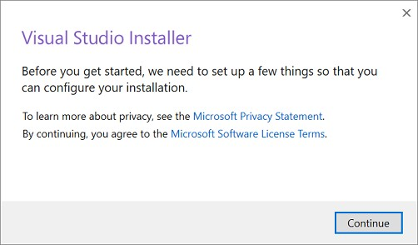

***Fig No:*** *4.3 Visual studio installer*

#### Step 4 - Choose workloads

After the installer is installed, you can use it to customize your installation by selecting the feature sets—or workloads—that you want. Here's how.

1. Find the workload you want in the **Visual Studio Installer**.

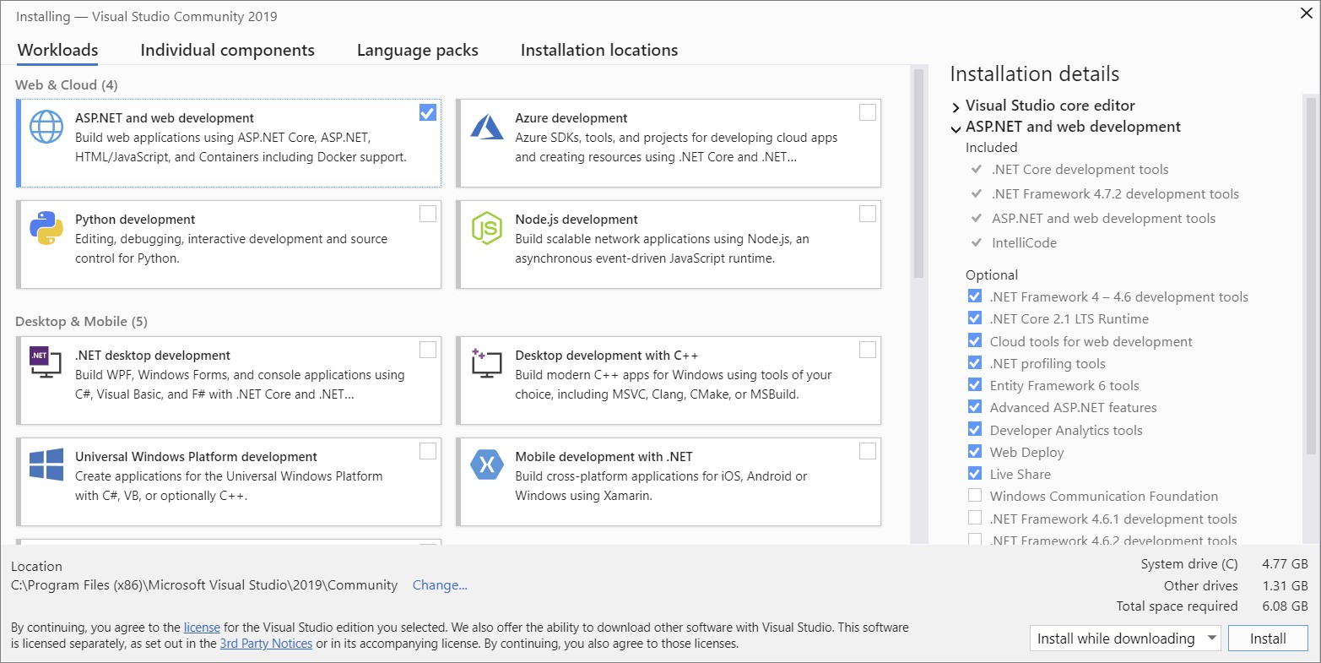

***Fig No:*** *4.4 work loads*

1. For example, choose the "ASP.NET and web development" workload. It comes with the default core editor, which includes basic code editing support for over 20 languages, the ability to open and edit code from any folder without requiring a project, and integrated source code control.
2. After you choose the workload(s) you want, choose **Install**.

Next, status screens appear that show the progress of your Visual Studio installation.

#### Step 5 - Choose individual components (Optional)

If you don't want to use the Workloads feature to customize your Visual Studio installation, or you want to add more components than a workload installs, you can do so by installing or adding individual components from the **Individual components** tab. Choose what you want, and then follow the prompts.

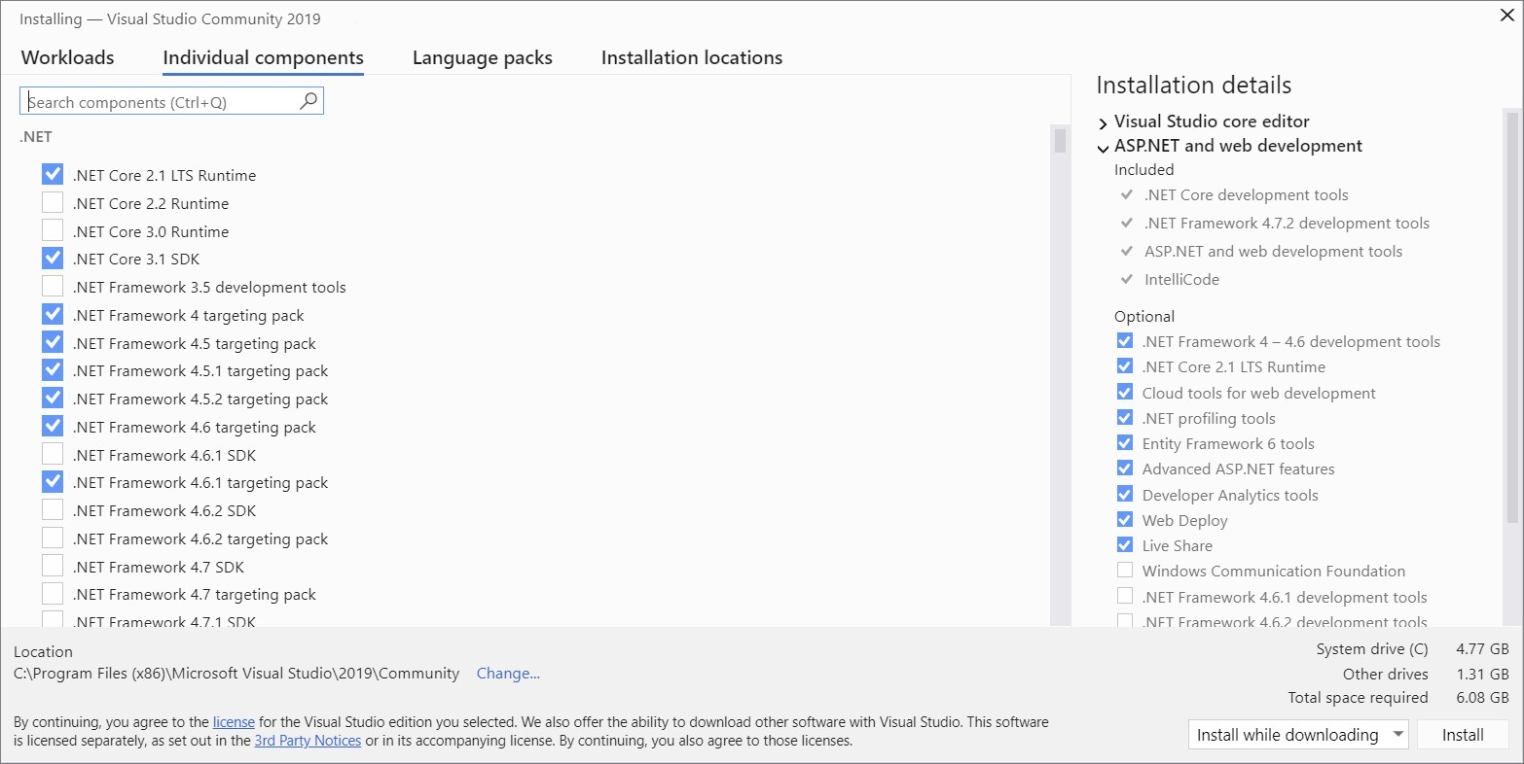

***Fig No:*** *4.5* Choose individual components

#### Step 6 - Install language packs (Optional)

By default, the installer program tries to match the language of the operating system when it runs for the first time. To install Visual Studio in a language of your choosing, choose the **Language packs** tab from the Visual Studio Installer, and then follow the prompts.

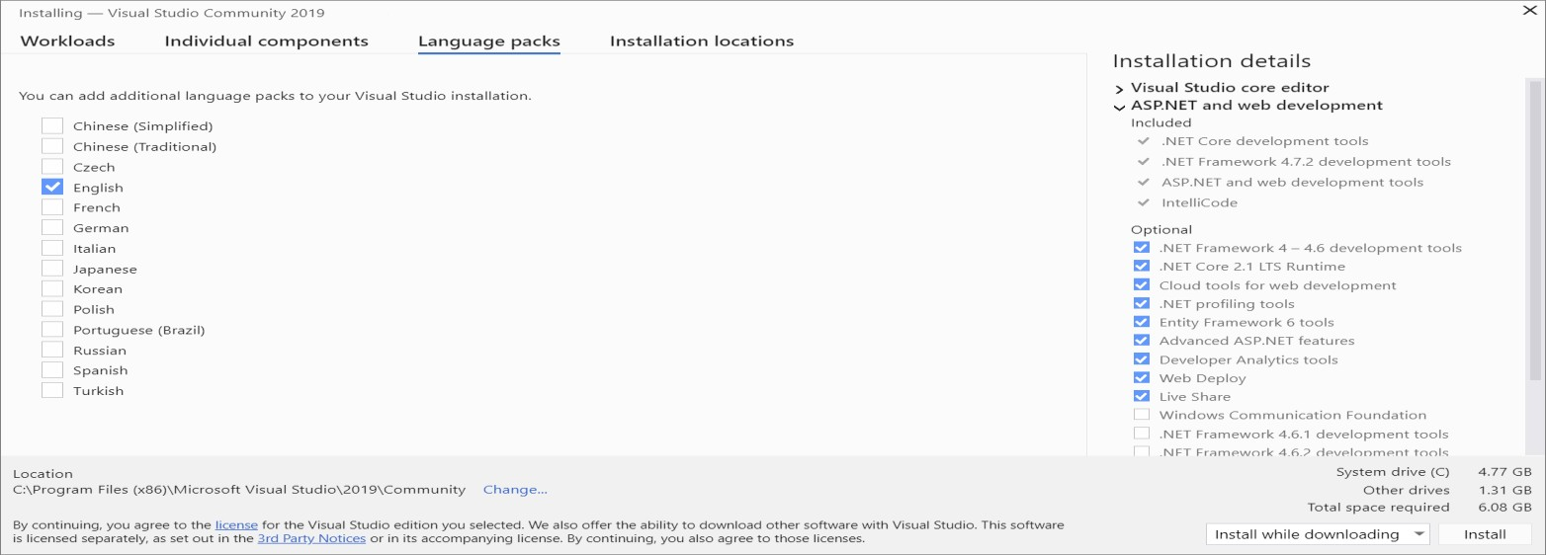

***Fig No:*** *4.6* Install language packs

Change the installer language from the command line

Another way that you can change the default language is by running the installer from the command line. For example, you can force the installer to run in English by using the following command: vs_installer.exe --locale en-US. The installer will remember this setting when it is run the next time. The installer supports the following language tokens: zh-cn, zh- tw, cs-cz, en-us, es-es, fr-fr, de-de, it-it, ja-jp, ko-kr, pl-pl, pt-br, ru-ru, and tr-tr.

#### Step 7 - Select the installation location (Optional)

You can reduce the installation footprint of Visual Studio on your system drive. You can choose to move the download cache, shared components, SDKs, and tools to different drives, and keep Visual Studio on the drive that runs it the fastest.

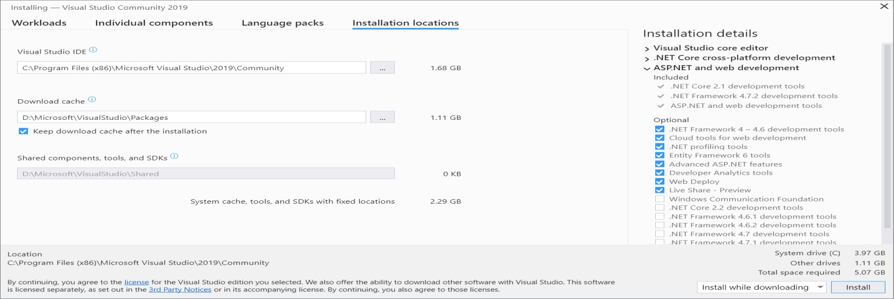

***Fig No:*** *4.7* Installation Location

#### Step 8 - Start developing

1. After Visual Studio installation is complete, choose the **Launch** button to get started developing with Visual Studio.
2. On the start window, choose **Create a new project**.
3. In the search box, enter the type of app you want to create to see a list of available templates. The list of templates depends on the workload(s) that you chose during installation. To see different templates, choose different workloads.

You can also filter your search for a specific programming language by using the **Language** drop-down list. You can filter by using the **Platform** list and the **Project type** list, too.

1. Visual Studio opens your new project, and you're ready to code!

#### User Documentation

User documentation needs to be consistent, simple and have a thorough index. It enables a user to understand the user interface better. It enables user to understand the Graphical User Interface (GUI) better. In this project, there are various options that would be carried out by various people. The proper manual has to be given in order to have feasible access with this system. The user is the most important subtasks of the developer. For this purpose user manuals are prepared and handled over to operate the developed system. Thus the users are trained to operate the developed system. Both hardware and software securities are made to run the developed system successfully in future. The users are trained to use the newly developed functions.

#### User guidance

Through the user guidance any user can interact with the system without any complexity to complete their task in a sophisticated manner.

#### Entering into website

Enter the <http://ewbqa.flextronics.com/>website and it will go to the respective page

#### BOM Scrubbing Page

The new users can gain access by providing the necessary details. The details will be showed in this grid.

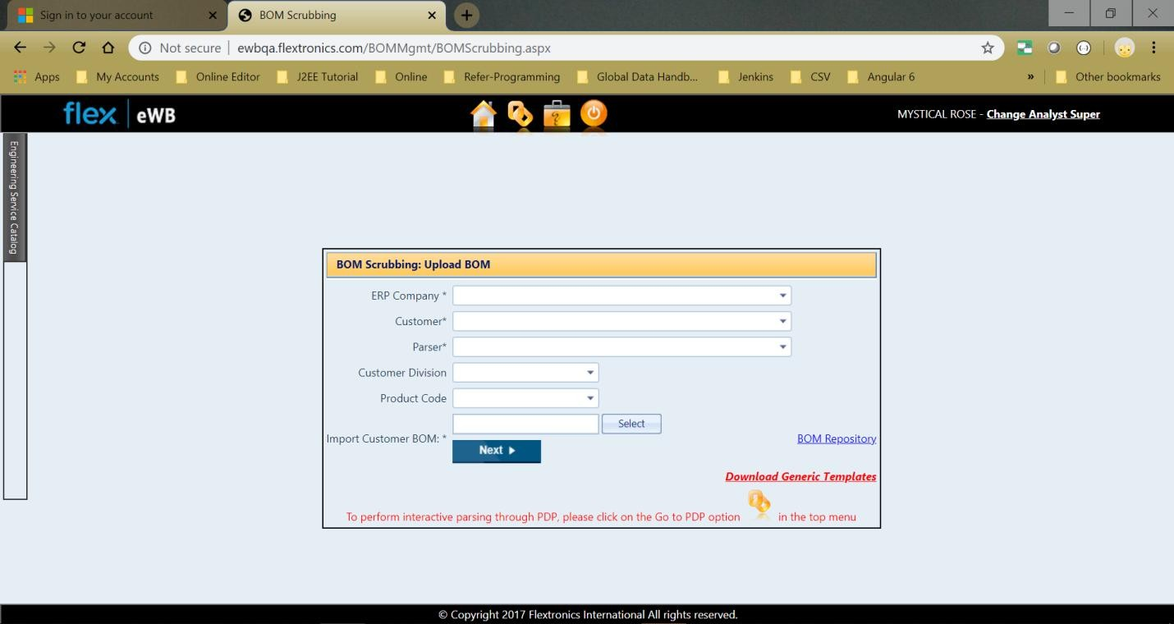

*Figure No: 4.8 BOM Scrubbing Page*

#### Save Versioned BOM Page

Then the details will be saved accordingly and displays if the file is a warning log or error log.

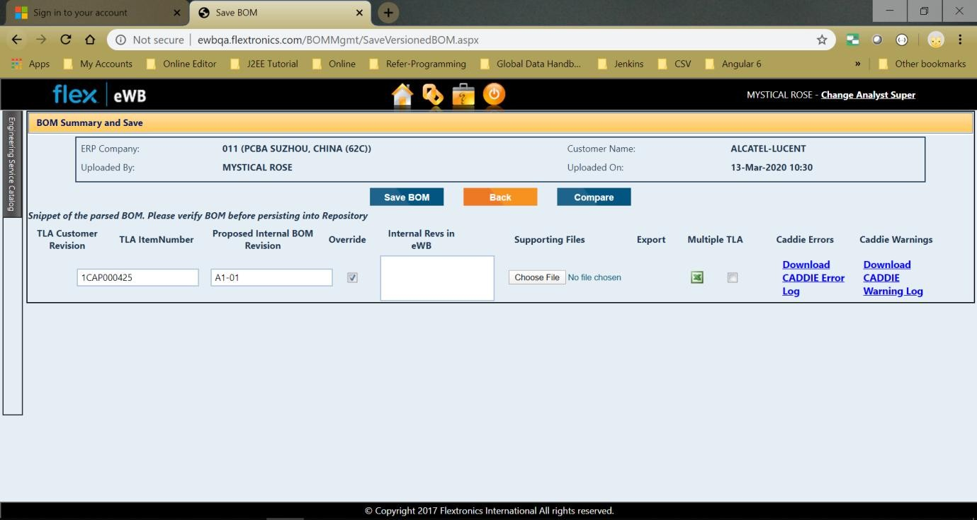

*Figure No: 4.9 save Versioned BOM Page*

#### BOM Repository Page

All the saved details are displayed in below screen:

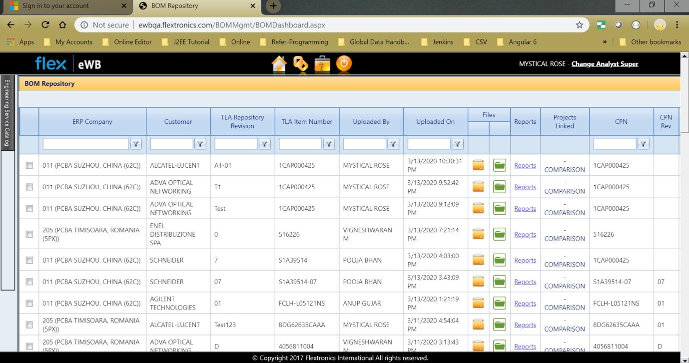

*Figure No: 4.10 BOM Repository Page*

#### Custom Reports Page

To generate as multiple files we use the customer report page.

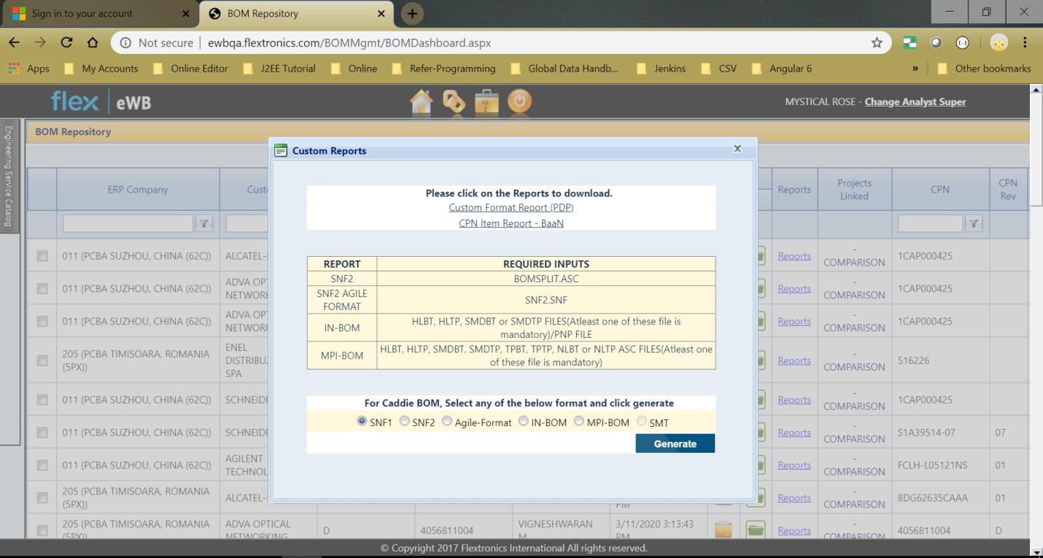

*Figure No: 4.11 Custom Reports Page*

#### Conclusion

The application was effectively tested under different strategies. Each functionality and sub-assembly was tested completely. Each and every test result was maintained in order to keep track of the whole testing phase. Various errors were detected and rectified for each strategy before moving on to the next one. Thus the system was tested completely and ensured that it meet the requirements and the users expectations.

# CHAPTER 5 CONCLUSION

#### Introduction

This chapter deals with the evaluation of the entire application in various views and then the future enhancement has to be taken into consideration. Finally, the chapter discusses in details about the technical skill that has been learned while developing the system.

#### Evaluation

Evaluation requires that the developers discard preconceived notions of the correctness of the software just developed and overcome a conflict of interest that occurs when errors are uncovered. If evaluation is encountered successfully, it uncovers errors in the software. Evaluation cannot show the absence of defect; it can only show that the software defects are present. Evaluation helps in determining the value and effectiveness of the system. Assessment and validation tools provide data for evaluation. Assessment is the measurement of the practical results of the training in the work environment; while validation determines if the objective of training goal were met

#### Evaluation checklist

The project is evaluated in two views. They are:

* + - * Administrator view
      * User view

#### Administrator view

The administrator is the one who controls the web application entirely. Since the administrator controls all operation, the application, must be evaluated whether it is flexible for the administrator while adding new menu items and inventory items, approve the details and user profiles, delete unwanted and obscene details

#### User view

It mainly deals with the verification of user satisfaction to meet the requirements. If the user is very comfortable with the application that leads him/her to share to his/her friends. The ease of use and responsive GUI, it can make the application simple and clear. Here are some evaluation checks that have been done which are linked to the objectives.

#### Let’s check their point of view.

|  |  |  |  |
| --- | --- | --- | --- |
| **EVALUATION CHECKLIST** | **YES** | **NO** | **N/A** |
| Is the web application pleasant look at? | ✔ |  |  |
| Did the application live up the expectations? | ✔ |  |  |
| Does the application is easy to use? | ✔ |  |  |
| Is there a consistent design scheme that facilitates or ease  the Data flow in case of any upload failure? | ✔ |  |  |
| Is there a visual representation of the business logic for  better understanding? | ✔ |  |  |
| Does the system operate even when interrupted by any  Network or logical error? |  | ✔ |  |
| Does the exit () closes the system abruptly without the  changes being saved? |  | ✔ |  |
| Are you satisfied with the overall application? | ✔ |  |  |

***Table No 6.1*** *Evaluation checklists*

#### Future enhancements

The future enhancements of CADDIE might be migrating the complete project to another technology like Angular or it may take different concepts as per customer’s requirement. The major enhance that will made in future are,

* Integration with AME Design Guide
* Automation in Actor Requests
* Auto Closure of Request
* Getting values for Existing Agile based on Item Revision
* Getting values for Existing Baan based on Item Revision

#### System Development

The most important fact of the system development is that is must be flexible enough for future modifications. The system has been designed and developed in such a way that it would be very easily upgraded for future requirements and flexible for future development. The project can be enhanced in a more efficient way so as to meet future development. In this system the NHibernate is used to solve the problem of impedance mismatch between class and relational databases and tables.

#### Technical skills learned

It has been a great pleasure to work on this exciting and challenging project that does in a flex organization. This project proved good as it provided practical knowledge of not only programming but also the knowledge of the best technologies which is being widely used nowadays. This project has helped to learn the following skills,

* I learnt Telerik Controls usingASP.NET
* I learnt How to build and deploy the real time projects
* I have experienced working in a real time project which helped me get exposed to different factors that play a main role in IT sector
* I learnt how to interact with senior employees through reports which is a key source of communication within a working environment
* I learnt security of code using Check Marx tool

#### Conclusion

This project has achieved the requirements and objectives that have been identified during analysis phase. Social Media Mining for Intent Analysis has helped to bring out solutions for several issues faced. Modifications after successful analysis can be incorporated into the system. The system has been well developed and future enhancements are also explained, so that it could be used to make any of the future modification; thus making the application more scalable and flexible.

**BIBLIOGRAPHY**

### Web Reference

* <https://stackoverflow.com/questions/12381563/how-to-stop-browser-back-button-using-javascript>
* <https://www.w3schools.com/jsref/jsref_undefined.asp>
* <https://www.tutorialspoint.com/csharp/csharp_arrays.htm>
* <https://www.codeproject.com/Questions/323723/>
* <https://www.encodedna.com/javascript/>
* <https://www.pluralsight.com/>

## APPENDIX SCREENSHOTS



BOM Scrubbing Page



Save Versioned BOM page



BOM Repository Page



Custom Reports Page